# Welfare & Distribution

## Cost

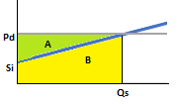

The cost is the area under the supply curve. In this segment of the supply curve, this is equal to Area B. To calculate this, first calculate Area A+B, as this is a simple rectangle, and subtract area A.

Area A+B = Qs * Pd

Area A = (Pd – Si) * Qs / 2

Where Si = supply intercept

To obtain this y intercept, set Q = 0 in the inverse supply expression:

(– a + Qs) / b

becomes

–a/b

Triangle A’s area is therefore:

(Pd – Si) * Qs / 2

(Pd – –a/b) * Qs / 2

(Pd + a/b) * Qs / 2

And area B is:

Qs * Pd – (Pd + a/b) * Qs / 2

## Welfare

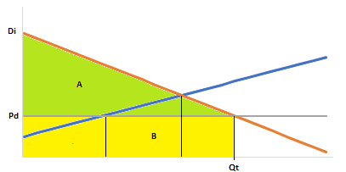

Total Benefit = A + B

Area B = Qt * Pd

Area A = Qt * (Di – Pd) / 2

Where Di = Demand intercept

Demand intercept is where q=0 in the inverse demand expression

(- c + qd) / d

Becomes

-c/d

Area A is therefore

Area A = Qt * (Di – Pd) / 2

Area A = Qt * (-c/d – Pd) / 2

A + B = Qt * Pd + Qt * (-c/d-Pd) / 2

A + B = (Pd - c / d) * Qt / 2

Qt(Pd) + Qt(-c/d-Pd)/2

Qt(Pd) -Qt(c/d)/2 + Qt(Pd)/2

Lee – need to understand how this has simplified

## Surpluses

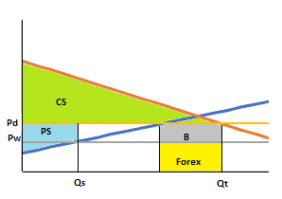

Expenditure is total spending on all of the good consumed and is equal to: **Pd * Qt**

Consumer surplus is CS, representing the difference of willingness to pay and price. It is equal to: **total benefit – expenditure**

Producer Revenue is the total spending on the domestically supplied product, and is equal to: **Qs * Pd**

Producer surplus is PS, and is equal to: **revenue – cost**

Government Budget is B and is equal to imports * tariff, or: **(Qt – Qs) * (Pd – Pw)**

Forex is the foreign exchange used to purchase imports and is equal to[1]: **(Qs – Qt) * Pw**

1. Stated here from the country perspective, not the importers. Hence it is a negative figure